**Proton Radiation Resilience of CdSeTe Photovoltaics: High Predicted End of Life Performance for Space Applications**

Zachary W. Zawisza, Scott Lambright, Patrick Chen, Aesha P. Patel, Molly Smith, Robert Snuggs Sabin Neupane, Samuel S. Erickson, Tamara Isaacs-Smith, James Becker, Don Walker, Abasi Abudulimu, Richard Irving, Yanfa Yan, Zhaoning Song, Randy J. Ellingson

**Abstract**

**Introduction**

The expansion and commercialization of orbital space activity for satellite and related asset deployment has driven demand for space-qualified photovoltaic (PV) power systems beyond the capacity of the conventional Group III-V multijunction (MJ) PV manufacturing industry. Power system design has expanded to include crystalline Si PV technologies, highlighting the need for innovative alternatives to III-V and Si for space power applications. Polycrystalline thin film PV has long been considered for space power, and recent advances in single junction device efficiencies have brought these technologies into focus – including perovskite-based as well as other thin film material platforms. The AM1.5 record efficiencies for perovskites, CdTe, and CIGS solar cells stand at 26.7%, 23.1%, and 23.6% (citation). With terrestrial utility scale PV now driving vigorous R&D into tandem technologies, higher efficiencies, which will close the gap with conventional MJ III-V cells, can be anticipated in the coming years.

Cadmium telluride (CdTe) solar cells have emerged as a promising candidate due to the potential for high specific power, radiation hardness, and low production costs (citations). Deepening our understanding of the behavior of these devices under proton irradiation remains crucial for assessing their viability in space missions, where radiation-induced damage is known to be a significant source of device degradation.

Previous studies on III-V semiconductor technologies, such as gallium arsenide/germanium (GaAs/Ge) solar cells, have established benchmarks and models for radiation degradation [1-8]. Though some work has been published exploring the response of CdTe PV devices and photodiodes to high-energy proton irradiation,[9-14] and at least one team has flown and measured CdTe PV devices in orbit [15], further studies will build confidence in evaluations of CdTe-based PV devices as a viable space power technology. Additionally, the CdTe PV industry has made several important changes to commercially available device stacks that are not fully reflected in previously studied devices, including the substitution of the cadmium sulfide window layer with cadmium selenide (CdSe) [16-19] and an ongoing effort to replace the conventional absorber layer p-type dopant from Cu to Group V pnictogen dopants, chiefly arsenic (As) [20-24]. In an effort to evaluate the radiation tolerance of the newer-generation cadmium selenide telluride (CdSeTe) based PV for orbital space missions, the authors have collaborated to expose industry-grade bifacial As-doped CdSeTe (CdSeTe:As) and Cu-doped CdSeTe (CdSeTe:Cu) PV devices to filmside-incident proton bombardment with energies in the range of 150 keV and 1000 keV and proton fluences from 1 x 1011 to 9 x 1013 cm-2. The current density vs. voltage (JV) characteristics and external quantum efficiency (EQE) have been measured for these industry-grade CdSeTe PV devices with and without proton irradiation. By quantifying the degradation of key device parameters, including power conversion efficiency (PCE, or η), short circuit current density (Jsc), open circuit voltage (Voc), and fill factor (FF), we simulate performance of these materials in low earth orbit (LEO) and other orbits. Additionally, we compare the results to GaAs/Ge cells to contextualize the findings in contrast to established space PV technologies. Through a combination of experimental data and damage modeling, this work provides insight into the performance of CdSeTe:Cu and CdSeTe:As PV devices in a simulated space radiation environment. The high end of life (EOL) predicted efficiencies based on this study highlights the potential of CdSeTe solar cells as a viable technology for space power generation.

**Materials and Methods**

Thin Film Stack Deposition and Processing

The starting thin film stack material used in this study consisted of nine square 100 cm2 soda-lime glass/proprietary front contact/CdSe/CdTe coupons, where the CdSeTe absorber was doped with either Cu or As, provided by First Solar, Inc. These absorber stacks were deposited on proprietary soda-lime glass/tin-oxide- (SnO) based substrates using vapor transport deposition (VTD) in a CdSe/CdTe bilayer. After breaking vacuum, the CdSe/CdTe films underwent a standard cadmium chloride- (CdCl2) assisted thermal anneal process in which recrystallization (grain growth) and interdiffusion between the CdSe and CdTe takes place, resulting in a larger-grain, graded CdSeTe absorber that was nearly pure CdTe at the back of the absorber. Following CdCl2-assisted thermal anneal, the zinc telluride (ZnTe) hole transport layer and proprietary transparent back contact (TBC) were deposited to complete the filmstack.

Device Finishing

After receiving the parent coupons, we scribed and snapped each of the 100 cm2 parent coupons into 16 individual 2.4 x 2.4 cm2 samples. Cell definition processing was performed using a 532 nm laser from the film side of the samples resulting in 18 or more 8.5 mm2 cells. An indium contact was soldered onto a strip of exposed front contact on the perimeter of each rectangular sample; all cells on the sample reside within 12 mm of this indium front contact, which minimizes variability in resistive loss.

Characterization

JV characteristic curves were measured for each of the samples described above under simulated AM1.5G and also under AM0 illumination (exposure duration about 3 s) at room temperature using a Keithley 2440 digital source meter unit and a LED solar simulator (MiniSol model LSH-7320) received from Newport. Dark JV curves were also recorded.

EQE was measured using a PV Measurements Inc. model IVQE8-C system, operated using custom PVIC-designed software.

The external radiative efficiency (ERE) and capacitance-voltage (CV) systems used in this study are detailed thoroughly in reference [25], and the results of those measurements on the samples of this proton irradiation study are discussed in the supporting information (SI) of this disclosure.

Light Soak Exposure and Additional Characterization

Light-soaking at moderately elevated temperature promotes defect annealing and concomitant improvements in performance. The light-soaking process was applied to both control samples as well as proton-irradiated samples. For light soaking of the CdSeTe devices, the sunnyside of the samples were exposed to about 100 mW/cm2 incident power from a mercury (Hg) vapor lamp (MVR1000) while the samples rested on a hotplate set to 70 oC for 24 hours. A previous study on the temperature of CdTe/Au devices under this light soak condition found the temperature of the samples’ filmside to stabilize around 90 oC, but in-situ temperature was not monitored during these tests. After prescribed light soak exposure intervals, the samples were removed from the Hg vapor lamp/hotplate apparatus, allowed to cool for 1-10 minutes, and both their glass-side incidence and film-side incidence JV before the samples were either stored in a dark cabinet or returned to the light soak apparatus.

SRIM Simulations and Proton Bombardment Conditions Selection

Figure 1: SRIM damage and range calculations for 150 keV (left) and 650 keV (right) proton incident on the filmside of CdSeTe device stacks.

Monte Carlo simulations of proton scattering and trajectory inside of the absorber material were obtained using SRIM 2013 software (Stopping and Range of Ions in Matter) [26]. Incident proton energies were chosen to enable study of lower energy (150 keV) protons which primarily implant in the absorber, and higher energy (650 keV) protons that primarily traverse the entire stack of electronic materials with relatively few interactions (see Figure 1). Proton beam fluences were chosen in consideration of the space radiation environment, with relevance to previous studies which have reported on the radiation hardness of CdTe based solar cells [9-11, 15]. Lamb et al. noted that their CdTe based solar cells remained at 95% of their initial PCE after irradiation with 500 keV protons to a fluence of 1012 cm-2 [10]. The proton bombardment process space sampled in this work included 11 conditions, with fluences of 1 x 1011, 1 x 1012, 1 x 1013, or 9 x 1013 cm-2 and proton energies of 150, 650, or 1000 keV.

Proton Bombardment

Photovoltaic device samples were exposed to proton bombardment using Auburn University’s accelerator, a 6HDS-2 Tandem, National Electrostatics Corporation Pelletron, with 2 sources for ions, an Alphatross (RF source for production of He+) and SNICS source (Source of Negative Ions by Cesium Sputtering). The SNICS source is used to produce proton by sputtering a titanium hydride cathode; the H- ions are selected for injection into the accelerating tube via an analysis magnet. The magnetic field bends just the desired ions into the accelerating tube, based on the mass and energy of the desired ion. As the ions are accelerated to the terminal energy, they pass through nitrogen gas, which removes electrons from the ions, neutralizing, and then reversing their polarity. Using the beam analyzing magnet post acceleration, the positive ion at the desired energy is then directed to the ion implantation chamber.

All of the irradiations are done in vacuum at a pressure of 3x10-6 torr or less at room temperature with cooling water flowing (55oF) through the sample holder to maintain samples at this temperature. The dose rate is kept constant for each irradiation. The proton beam is scanned over a 6.3 cm diameter circle. The scan rate is 517 Hz in the x-direction and 64 Hz in the y-direction. The current is periodically measured using a Faraday Cup located approximately 30 inches up stream of the sample. The uniformity of current is maintained by measuring equal currents in all four isolated and biased Faraday Cups located about the aperture plate. The circuit is grounded to prevent charging.

Travel-and-handling witness samples were also shipped from U-Toledo to Auburn and back to check for performance degradation from shipping, handling, and sample exposure to the ambient. Finally, proton exposure was performed in two batches, with the first batch being exposed on the week of April 22nd of 2024 and the second batch being exposed on the week of September 2nd, 2024.

Displacement Damage Dose Analysis

As energetic protons travel through the absorber layer, they interact with the atoms in the lattice via a number of different scattering or collision mechanisms, leaving some or all of their energy behind. In general, these energy loss mechanisms can be classified as either ionizing energy loss (IEL) or non-ionizing energy loss (NIEL) [1-3], and the proportion of IEL vs NIEL depends upon the proton energy. The dependence of interaction and damage on particle energy has led to the creation of multiple solar cell degradation models such as the displacement damage dose (DDD) method, and the relative damage coefficient (RDC) method. Radiation studies on a variety of technologies including silicon and GaAs/Ge have shown that there is typically a linear dependence between the proton damage coefficients and the absorber’s NIEL curve [5]. The DDD method takes advantage of this linear relationship and allows us to characterize, model, and predict CdSeTe cell degradation with fewer ground measurements as compared to the RDC method. The NIEL curve was obtained for CdTe from screened relativistic NIEL (SR-NIEL) [27]. The NIEL curve calculation was performed using the Robinson partition function with threshold displacement energies experimentally determined as described in [27, 28]. DDD represents the product of the fluence and the NIEL at a given incident proton energy for a specific material. The significance of the DDD (units of MeV/g) becomes clear when evaluating a solar cell’s performance parameter as a function of DDD. The damage curves of differing proton energies show a solar cell’s parameter of interest vs. DDD (dose) and have been fit with equation (1) [8].

(1)

Next, the SPace ENVironment Information System (SPENVIS) software was used to obtain a differential proton spectrum for a 400 km circular orbit with inclination of 51.6° relative to the equatorial plane [29]. Finally, to obtain an end-of-life (EOL) prediction, the product of the differential proton fluence and the NIEL was integrated over the aforementioned proton energy spectrum giving a DDD incurred by a solar cell during the orbital mission of specified duration.

**Results**

Current Density-Voltage Characteristics

For each of the four JV parameters (PCE, Voc, FF, and Jsc), the relative difference between the post-proton-exposure performance and control performance was calculated. These differences in performance will be reported as “dPCE”, “dVoc”, “dJsc”, and “dFF”, with each of these being calculated thusly:

(2)

This will allow for direct comparison of Voc, FF, and Jsc parameters in their contributions to overall PCE losses. Please note that, as opposed to the usual remaining factor method frequently used to evaluate a device’s radiation hardness [10] in which a particular PV cell’s post-exposure performance is compared to that same cell’s pre-exposure performance, we compare the post-exposure performance of a given 2.4 x 2.4 cm2 sample to the median performance measured for control devices taken from the same parent coupon, with all samples being characterized during the same characterization session. Please see SI section 1 for justification of this method.

Each datapoint (dot) in the JV side-by-side box plots of Figures 2, 11, 12, and 13 represents the median JV parameter value for a 2.4 x 2.4 cm2 sample of numerous 8.5 mm2 cells. The authors would argue that averaging over the cells of a given sample and analyzing at the “sample-level” is appropriate given that the processing experienced by any given cell on a sample is highly correlated with the processing experienced by any other cell in that sample (cells on a given sample are only ever ~20 mm away from each other during treatments, at most) and that the trends and phenomena of interest in this study only emerge in the differences at the “sample-level.”

Figure 2, along with Figures 11-13 of SI section 2, consist of side-by-side box plots illustrating the sunnyside-incidence JV parameters of both CdSeTe:As and CdSeTe:Cu PV devices after their exposure to proton bombardment. The first notable trend is that no more than -5% dPCE degradation signal is observed for samples exposed to the lowest proton fluence (1*1011 cm-2), regardless of proton energy or p-type absorber dopant. At higher fluences from 1 x 1012 to 1 x 1013 cm-2, samples demonstrate -5% to roughly -70% dPCE relative to controls, with the degree of PCE damage highly correlated with the fluence order-of-magnitude and weakly, negatively correlated with proton energy. Six samples were exposed to 9 x 1013 cm-2 at either 650 or 1000 keV; both of these most aggressive irradiation conditions result in at least -80% dPCE, with the As-doped 650-keV-exposed sample exhibiting an absolute PCE of 0.3% and the As-doped 1000-keV-exposed samples showing a marginally-better 0.6% absolute PCE.

For the three lower fluence levels, losses in Voc, FF, and Jsc all contribute to PCE trends; for example, at 650 keV and 1012 cm-2, dVoc and dJsc are observed to be -3% relative to controls while dFF is -12% (SI section 2, Figures 11-13). At the most damaging conditions (highest fluence at each proton energy), the dPCE trend is overwhelmingly (and intriguingly) driven by extremely poor Jsc.

Though the general trends of JV performance loss is similar between CdSeTe:As devices and CdSeTe:Cu devices, it is clear from comparing the left and right sides of Figure 2 that Cu-doped devices are somewhat more resilient to proton damage across the process space explored in this study. For example, at the 650 keV, 1 x 1012 cm-2 irradiation condition, the median Cu-doped device shows only about -7% dPCE compared to -16% dPCE for As-doped devices, whereas at the 1000 keV, 9 x 1013 cm-2 condition, Cu-doped devices show merely -80% dPCE compared to -95% dPCE for As-doped devices. This observation is corroborated with a linear regression model predicting dPCE from p-type dopant and proton-exposure parameters (SI section 3). Here, the correlation of the degree of damage with proton-fluence is contingent on the absorber dopant (i.e. the interaction between fluence and p-type dopant is statistically significant; see Table 1).

Filmside JV PCE and Jsc side-by-side boxplots are shown in SI section 4. Though filmside JV performance largely follows degradation trends similar to sunnyside JV, the As-doped samples exposed to the highest fluence at each proton energy level show an unexpected upturn in PCE relative to lower-fluence samples. In fact, the As-doped devices that were exposed to 1 x 1013 cm-2 at 150 keV demonstrated a PCE enhancement relative to unexposed controls (6.7% vs. 4.3%). This PCE upturn is driven by enhanced filmside Jsc. The authors have two explanations for this unexpected observation.

Some PV technologies have shown self-healing via an annealing process, even at moderate temperatures (e.g. < 100 oC) (citation), and we have investigated such effects for these irradiated cells. Batch 1 samples (irradiation completed in April 2024) that were exposed to 1013 cm-2 were subsequently exposed to approximately 70 oC, 1-Sun light soak processing for two weeks, with their JV characteristics measured after 1 hour, 1 day, 1 week, and 2 weeks of light soak. While Cu-doped devices exhibit some recovery (starting between 13-15% PCE and recovering to around 16% PCE after two weeks light soak), As-doped devices show very little recovery (stable after 1-hour light soak “wake-up” [20]). Please refer to SI section 8 for recovery-study plots.

External Quantum Efficiency

A single cell from each sample underwent EQE measurement during each round of characterization. However, it was found that samples of either p-type dopant exposed to 1011 cm-2 at any energy explored in this study did not deviate appreciably from EQE curves of controls (SI section 5). For the sake of clarity, only samples exposed to proton bombardment have been included in the following charts.

EQE measurements (Figure 3) closely follow the trends observed in the Jsc of the JV characteristic curves: namely, (1) no significant difference can be observed in EQE at fluences below 1013 cm-2, (2) some degradation of EQE is demonstrated for 650 and 1000 keV at 1013 cm-2, and (3) catastrophic damage is observed in the EQE for the highest fluence at each proton energy. As with their JV response, the EQE response of Cu-doped CdSeTe PV devices show less change than As-doped devices. Specifically, the As-doped devices show nearly complete extinction of the EQE response for the most aggressive bombardment condition, while Cu-doped devices dropped to about 25% for the maximum EQE value.

The EQE degrades independent of wavelength, as opposed to damage specifically affecting blue or red current collection. This broadband EQE degradation suggests a lower charge carrier lifetime in the absorber bulk for highly-irradiated samples [30].

**(e)**

**(d)**

**(c)**

**(b)**

**(a)**

Figure 2: Top) Sunnyside excitation incidence PCE for CdSeTe:As and CdSeTe:Cu devices after proton bombardment, along with unexposed controls. Middle) Relative difference in PCE compared to witness device performance. Red dots indicate samples from batch 1 and blue dots indicate samples from batch 2. Bottom) Example JV curves for As-doped CdSeTe PV devices. Left: control device. Middle: device exposed to 150 keV/1011 cm-2. Right: device exposed to 150 keV/1013 cm-2.

Figure 3: Top) Sunnyside EQE for proton+-exposed arsenic-doped CdSeTe PV devices. Bottom) The same for copper-doped CdSeTe devices.

DDD Analysis and Curve Fit

In order to quantify the degradation in performance parameters as a function of absorbed displacement damage dose, we graph and analyze the remaining factor vs. the DDD for all fluences of our fully penetrating proton energies. Fits of Equation (1) to the normalized PCE, Voc, and Jsc were completed, and show good fits (R2 at least 0.93 for each) for both As- and Cu-doped samples (Figures 4 and 5). Notably, the FF of As-doped devices vs. DDD does not fit well to Equation 1 for the highest fluence values. One Cu-doped sample performed abnormally poorly in PCE, Voc, and FF compared to sample replicates.

Excluding the FF fit due to the lack of a representative curve for As-doped devices, we find higher radiation tolerance of the main device parameters of interest, including PCE, for CdSeTe:Cu devices as compared to CdSeTe:As. A direct comparison of the solar cell PCE degradation as predicted by DDD analysis is shown in Figure 6 for both this study’s CdSeTe devices and literature GaAs/Ge devices. While CdSeTe:Cu and CdSeTe:As curves are similar to each other, the curve for Cu-doped devices demonstrates a distinct advantage. Both As and Cu devices show significantly less degradation than GaAs/Ge for a given DDD. A comparison of the predicted normalized PCE for unshielded CdSeTe:Cu, CdSeTe:As, and GaAs/Ge devices in a simulated 400 km LEO orbit makes the superior radiation tolerance of CdSeTe solar cells clear (Figure 7).

Figure 4: DDD degradation curve fit of As-doped CdSeTe for PCE, Jsc, Voc, and FF (top left, top right, bottom left, bottom right respectively).

Figure 5: DDD degradation curve fit of Cu-doped CdSeTe for PCE, Jsc, Voc, and FF (top left, top right, bottom left, bottom right respectively).

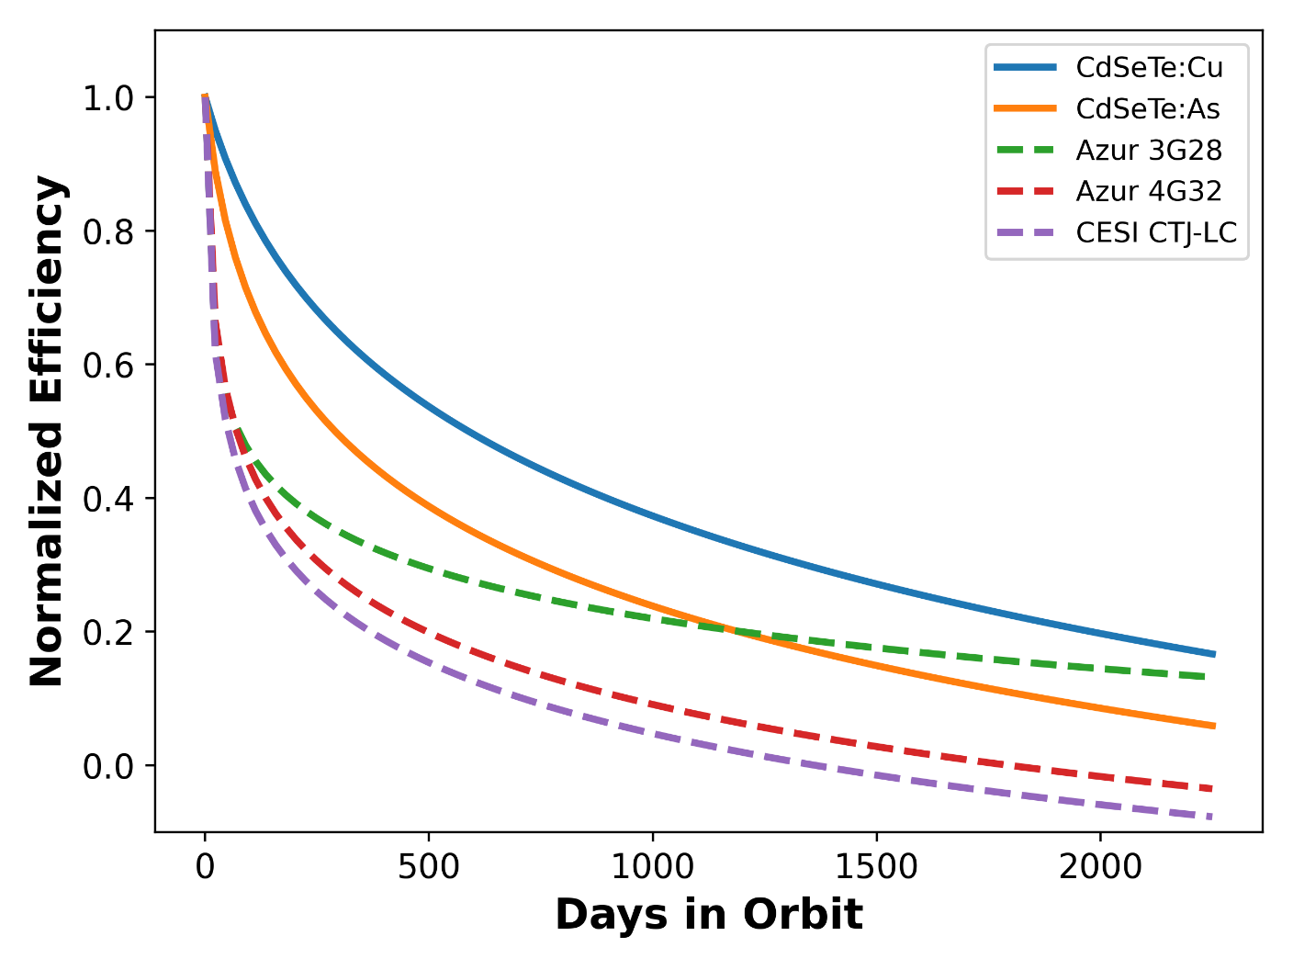

Figure 6: Comparison of the predicted degradation for present work (solid) and relevant competing space solar cells (dashed) vs time spent in a 5000km, 60 degrees inclination circular orbit with no shielding.

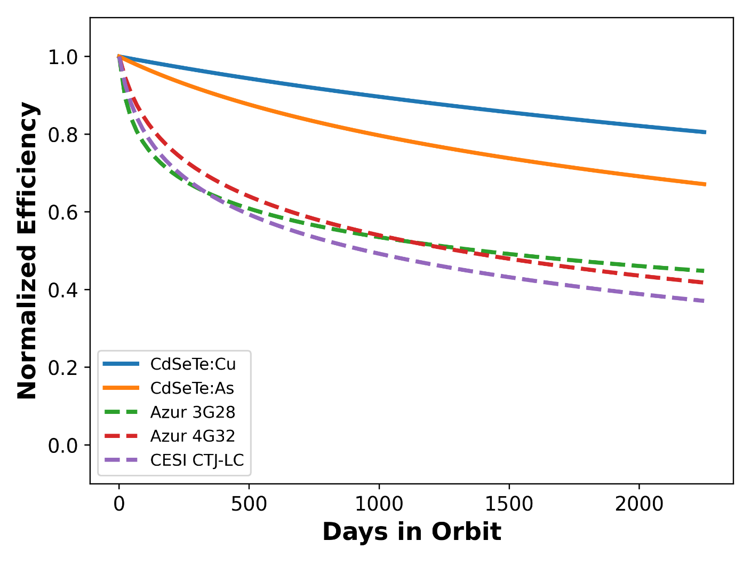

Figure 7: Comparison of the predicted degradation for present work (solid) and relevant competing space solar cells (dashed) vs time spent in a 5000km, 60 degrees inclination circular orbit with 150um of SiO2 shielding.

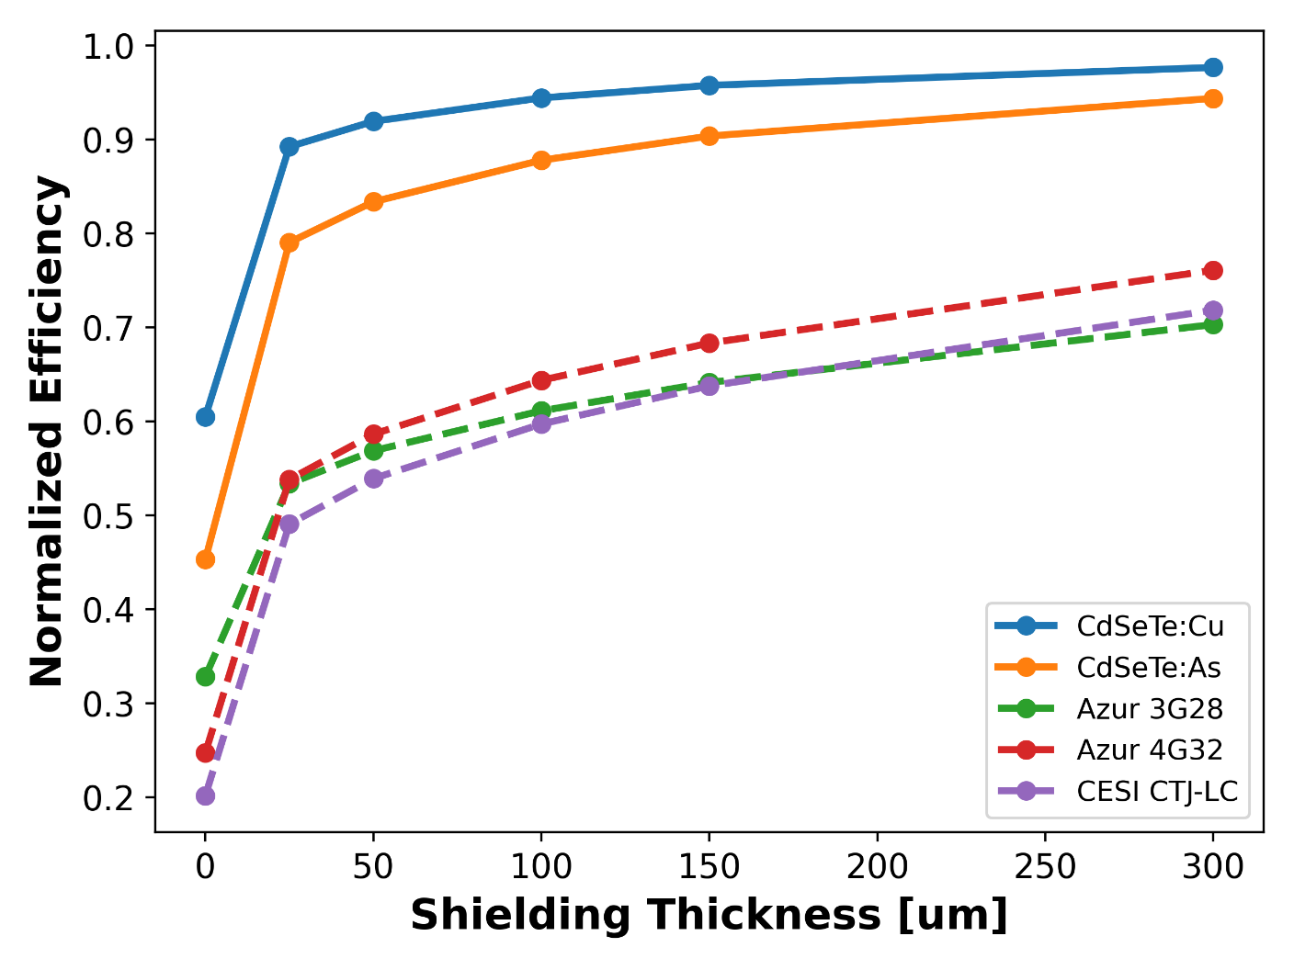Figure 8: Comparison of the predicted end of life efficiency for present work (solid) and relevant competing space solar cells (dashed) vs thickness of SiO2 shielding after one year in a 5000km, 60 degrees inclination circular orbit.

**Discussion**

The present proton radiation study provides evidence that CdSeTe solar cells perform quite well with proton irradiation compared to competing technologies. The relative radiation hardness of CdSeTe devices would allow for choices of thinner space cover glass (SCG) while still respecting mission requirements if chosen appropriately as shown in Figure 8. While shielding can significantly reduce the radiation-induced degradation of the device, it should be noted, as shown in Figure 8, that overcoming a large difference in degradation between materials with solely SCG is impractical. Further, including thicker and thicker SCG serves to increase weight considerably and reduce the specific power of the module. More work is needed to understand the behavior of FF vs proton irradiation for CdSeTe:As devices. The fitted damage curves, while based on limited data, allow for prediction of performance in specific orbits of interest along with the effects of shielding. This allows for CdSeTe based PV devices to be added to considerations during mission planning and analysis. More data, and more energies in particular, will improve the DDD model’s ability to accurately predict CdSeTe solar cell performance in orbit.

**Conclusions**

Industry-grade bifacial CdSeTe:As and CdSeTe:Cu PV devices have been exposed to high-energy proton irradiation between 150 and 1000 kV acceleration voltage and between 1 x 1011 and 9 x 1013 cm-2 fluences. Both sunnyside and filmside JV characteristic and EQE response, along with ERE and Na measurements by way of CV, been measured before and after proton irradiation for said devices. At all particle acceleration voltages explored in this study, device JV demonstrated some PCE damage for 1012-1013 cm-2 fluence (between -5% and -70% dPCE), while catastrophic damage to JV and EQE are demonstrated by devices exposed to fluences 9 x 1013 cm-2 or more (at least -80% dPCE). Superior radiation hardness of CdSeTe devices, as compared to GaAs/Ge literature values, are demonstrated in DDD analysis and EOL simulations. Additional proton irradiation experiments at higher energy levels are needed to verify these results. Defect studies, including deep-level transient spectroscopy, photoluminescence, transient photovoltage and transient photocurrent, are ongoing in an effort to explain the observed device performance differences at a more fundamental level.

**Acknowledgements**

This disclosure is based on research sponsored by Air Force Research Laboratory under agreements FA9453‐19‐C‐1002 and FA9453‐21-C-0056, and by the U.S. DOE’s Office of Energy Efficiency and Renewable Energy (EERE) under the Solar Energy Technologies Office (SETO), through agreement DE-EE0008974, and through the Alliance for Sustainable Energy, LLC, Managing and Operating Contractor for the National Renewable Energy Laboratory for the U.S. Department of Energy, under award number 37989. The U.S. Government is authorized  to reproduce and distribute reprints for Governmental purposes notwithstanding any copyright notation thereon.  The views and conclusions contained herein are those of the authors and should not be interpreted as necessarily representing the official policies or endorsements, either expressed or implied, of Air Force Research Laboratory or the U.S. Government. Approved for public release; distribution is unlimited. Public Affairs release # AFRL-________. Finally, the CdSeTe absorber material used in this study was provided by First Solar, Inc.

Supporting Information

SI Section 1: Variations in JV parameters in devices unexposed to proton-bombardment

CdSeTe:As devices demonstrate expected sunnyside-excitation JV performance before light soak exposure, with devices exhibiting between 12% - 16% power conversion efficiency (PCE) (Figure 8). There is considerable variation amongst the five 100 cm2 CdSeTe:As parent coupons being used in this experiment, with an approximate 1.1% absolute PCE spread over coupon medians. Open-circuit voltage (Voc), short-circuit current density (Jsc), and fill factor (FF) contribute to said coupon-coupon PCE variation. The authors posit that these initial JV differences are either due to As-doping concentration or As-activation differences across the width and breadth of the CdSeTe absorber [31, 32], which was deposited in about 1 m by 3 m sheets [20]; deposition and processing conditions could vary significantly with such large batch processing areas.

The sunnyside JV device performance differences between the four 100 cm2 CdSeTe:Cu coupons are much smaller in magnitude compared to those seen in the CdSeTe:As devices. Median PCE of devices made from the two coupons are 17.7% and 18.3%, which are within one standard error of each other (Figure 9). Voc and FF account for most of the initial PCE differences in the Cu-doped devices.

In response to these two sources of variability, the authors will focus on comparing proton-exposed samples to unexposed controls that were 1) taken from the same parent 100 cm2 coupon, and 2) characterized during the same session as the post-exposure sample in question. That is to say, post-exposure devices from parent coupon #1 will be compared with post-shipment controls taken from that same parent coupon #1, exposed devices from parent coupon #2 will be compared with post-shipment controls taken from coupon #2, etc. This is markedly different from the method in reference [10], for example, in which the pre-exposure and post-exposure device character of a given cell is compared directly; however, the major difference between results obtained using this method and those obtained by comparing a cell’s performance directly with its pre-proton-exposure performance is that fewer and lower magnitude positive JV performance changes are calculated for samples that were undamaged or lightly damaged by proton exposure.

*Figure 8: Sunnyside excitation incidence JV parameters for all CdSeTe:As devices before proton bombardment.*

Figure 9: Sunnyside excitation incidence JV parameters for all CdSeTe:Cu devices before proton bombardment.

SI Section 2: Sunnyside-incidence current density-voltage characteristic parameters of proton-exposed PV devices

As explained in the previous section, the following Voc, Jsc, and FF data shown in Figures 11-13 are all from devices post-exposure, alongside control data taken from each 100 cm2 parent coupon measured at the same time for comparison. Again, dVoc, dJsc, and dFF are calculated thusly:

.

The vertical axis for the side-by-side box plots for dVoc, dJsc, and dFF have the same range (+10% to -100%) so that the three can be easily compared for their contributions to dPCE (Figure 2 of the main article).

Figure 11: Top) Sunnyside excitation incidence Voc for CdSeTe:As and CdSeTe:Cu devices after proton bombardment, along with unexposed controls. Bottom) Relative difference in Voc compared to witness device performance. Red dots indicate samples from batch 1 and blue dots indicate samples from batch 2.

Figure 12: Top) Sunnyside excitation incidence Jsc for CdSeTe:As and CdSeTe:Cu devices after proton bombardment, along with unexposed controls. Bottom) Relative difference in Jsc compared to witness device performance. Red dots indicate samples from batch 1 and blue dots indicate samples from batch 2.

Figure 13: Top) Sunnyside excitation incidence FF for CdSeTe:As and CdSeTe:Cu devices after proton bombardment, along with unexposed controls. Bottom) Relative difference in FF compared to witness device performance. Red dots indicate samples from batch 1 and blue dots indicate samples from batch 2.

SI Section 3: Multivariable polynomial linear regression model predicting dPCE as a function of absorber p-type dopant and proton-exposure conditions

A least-squares-fitted multivariable linear regression model was constructed using the “Fit Model” platform of JMP Pro 18 in which the CdSeTe p-type dopant (As vs Cu), the log10 of proton fluence, and the proton acceleration voltage were used as explanatory variables and the 0-hour lightsoak, sunnyside, AM1.5G dPCE data as the response (Figures 14-16 and Table 1). In addition to these 1st order explanatory terms, all 2nd order terms (quadratic term of log10(fluence), quadratic term of acceleration voltage, and two-way interactions of all 1st order terms) along with the three-way interaction of 1st order terms were included in the explanatory variables. As shown at the bottom of Figure 14, this model has a coefficient of determination, or “R2”, of 0.92, meaning that the majority of the variation in this data set is correlated with intentionally varied process input terms and interactions thereof. Note in particular that the interaction term of CdSeTe p-type dopant and fluence is significant; this indicates that Cu-doped CdSeTe device response is less negatively correlated with proton fluence as compared to As-doped CdSeTe devices.

Figure 14: Predicted median dPCE vs. actual median dPCE scatterplot with line-of-best-fit for dPCE linear regression model.

Figure 15: Top) Residual and bottom) studentized residual of dPCE least-squares-fitted linear regression model.

Table 1: Linear regression model predicting dPCE using CdSeTe p-type dopant and proton-bombardment process condition.

|  |  |  |  |  |
| --- | --- | --- | --- | --- |
| Process Input Term | Estimate (% rel. to controls) | Std Error | t Ratio | Prob>|t| |
| Intercept | 282.07204 | 13.96043 | 20.21 | <.0001 |
| **CdSeTe p-Type Dopant[Arsenic]** | **-4.48775** | **1.062219** | **-4.22** | **<.0001** |
| **log(Fluence)** | **-25.09346** | **1.137288** | **-22.06** | **<.0001** |
| **(log(Fluence))2** | **-11.56407** | **1.305617** | **-8.86** | **<.0001** |
| **Proton Acceleration Voltage (kV)** | **0.0105825** | **0.00337** | **3.14** | **0.0027** |
| (Proton Acceleration Voltage (kV))2 | 1.66E-05 | 1.28E-05 | 1.3 | 0.1991 |
| **CdSeTe p-Type Dopant[Arsenic] * (log(Fluence))** | **-4.833212** | **1.125128** | **-4.3** | **<.0001** |
| CdSeTe p-Type Dopant[Arsenic] * (Proton Acceleration Voltage (kV)) | 0.0031082 | 0.003115 | 1 | 0.3225 |
| **(log(Fluence)) * (Proton Acceleration Voltage (kV))** | **0.0116896** | **0.003586** | **3.26** | **0.0019** |
| CdSeTe p-Type Dopant[Arsenic] * (log(Fluence)) * (Proton Acceleration Voltage (kV)) | 0.0086476 | 0.003461 | 2.5 | 0.0153 |

Figure 16: Linear regression model prediction profiles, with which a predicted dPCE value can be calculated by setting the sliders to particular values of CdSeTe p-type dopant, log(fluence), and proton acceleration voltage. Note that the slope of the dPCE vs. log(fluence) prediction profile (middle profile in each) becomes more negative when dopant type is set to “arsenic” as opposed to “copper” (left box in each).

SI Section 4: Unexpected trends in filmside JV and EQE

Figure 17: Top) Filmside excitation incidence PCE for CdSeTe:As and CdSeTe:Cu devices after proton bombardment, along with unexposed controls. Bottom) Filmside excitation incidence Jsc for CdSeTe:As and CdSeTe:Cu devices after proton bombardment, along with unexposed controls. Red dots indicate samples from batch 1 and blue dots indicate samples from batch 2.

*Figure 18: Top) Filmside EQE for proton-exposed arsenic-doped CdSeTe PV devices. Bottom) The same for copper-doped CdSeTe devices.*

SI Section 5: EQE comparison of unexposed devices and devices exposed to low-fluence bombardment

Figure 19: Post-exposure device EQE (highlighted blue) and unexposed control EQE (unhighlighted red).

SI Section 6: External Radiative Efficiency

At higher proton energies, external radiative efficiency (ERE) tends to decrease monotonically with increased fluence (Figure 20). This is unsurprising; proton accelerated under these voltages are expected to pass through the entirety of the thin film device and not embed themselves into any of the active semiconductor layers. Collision cascade events are not expected for the tested energy range [33] and it is reasonable to assume that defect and recombination center density throughout an exposed device is directly proportional to the number of incident proton multiplied by the number of first-order collision events per proton.

The samples exposed to 150 keV proton exhibit an altogether different response to bombardment fluence; for both CdSeTe:As and CdSeTe:Cu devices, ERE is largely unaffected by low proton fluence and enhanced at 1013 cm-2. 150 keV proton are expected to embed in the first 1.5 µm of the device; the authors hypothesize that either enhanced p-type (hydrogen) doping or possibly a high-temperature/short-time-interval process similar to rapid thermal annealing at the back of the absorber might be responsible for this elevated PL intensity (i.e. hydrogen passivation of defects, as in a-Si).

*Figure 20: External radiative efficiency for batch 1 samples post-proton-exposure. Note that parent coupon (indicated with dot color) accounts for much of the spread in the data, especially in the arsenic-doped case.*

SI Section 7: Capacitance-voltage data

A large difference between As-doped and Cu-doped device response is observed again in the CV-derived charge carrier density-depletion width curves, but this time the response is tied to a large initial difference in measured acceptor density (Na). As is widely known in the CdTe PV community [20-22], pnictogen doping (N, P, As, Sb, Bi) facilitates much higher Na as compared to Cu doping, which self-compensates at higher concentrations. It is then not surprising that initial CdSeTe samples demonstrate Na of only 2 x 1013 cm-3 in Cu-doped devices but 6 x 1015 cm-3 in As-doped devices (bottom of the “U”-shaped curve, Figure 21) . In the 650 and 1000 keV exposure conditions (Figure 22), Cu-doped devices only demonstrate decreased Na by a factor of 2 or 3 compared to controls, where As-doped absorbers are reduced from 6 x 1015 to 3 x 1013 cm-3 in the high-fluence conditions. It is known in the CdTe PV community that small-ionic-radius Cu ions easily diffuse into all layers of a thin film device once introduced [34] while As is subject to a much more prohibitive diffusion coefficient [21, 23]. It is still unclear what species of defects are introduced in this set irradiated samples. Defect studies currently underway include deep-level transient spectroscopy [25], room temperature and cryogenic photoluminescence (spectrally and temporally resolved) [35], and transient photovoltage and photocurrent [36, 37].

It should be noted that charge carrier density profiles seem to be less affected in the case of 150 keV protonbombardment. SRIM simulations suggest that 150 keV proton would stop only 1.5 µm into the device stack; this might barely reach the outer edge of the extended CdSeTe region that is believed to constitute the pn junction region in industry CdSeTe-based PV devices [20]. It is possible that a smaller fraction of proton collision events are taking place deep enough into these devices to be relevant to determining Na.

Figure 21: Na as a function of depletion width for pre-proton-exposure CdSeTe PV devices.

Figure 22: Top) Na as a function of depletion width for post-proton-exposed devices arsenic-doped CdSeTe PV devices, taken from CV curves. Bottom) The same for copper-doped CdSeTe devices.

SI Section 8: Recovery anneal JV as a function of time exposed to 70 oC/1-Sun light soak

Figure 23: Sunnyside PCE, dPCE, and Voc*FF for batch 1 samples exposed to 1013 cm-2, along with controls, as a function of 70 oC/1-Sun light soak exposure over 2 weeks.

**References**

1. Claeys, C. and E. Simoen, *Radiation effects in advanced semiconductor materials and devices*. 2010: Springer.

2. Burke, E.A., *Energy Dependence of Proton-Induced Displacement Damage in Silicon.* IEEE Transactions on Nuclear Science, 1986. **33**: p. 1276-1281.

3. Simon, G.W., J.M. Denney, and R.G. Downing, *Energy Dependence of Proton Damage in Silicon.* Physical Review, 1963. **129**(6): p. 2454-2459.

4. Summers, G.P., et al. *A new approach to damage prediction for solar cells exposed to different radiations*. in *Proceedings of 1994 IEEE 1st World Conference on Photovoltaic Energy Conversion - WCPEC (A Joint Conference of PVSC, PVSEC and PSEC)*. 1994.

5. Summers, G.P., E.A. Burke, and M.A. Xapsos, *Displacement damage analogs to ionizing radiation effects.* Radiation Measurements, 1995. **24**(1): p. 1-8.

6. Summers, G.P., et al., *Low energy proton-induced displacement damage in shielded GaAs solar cells in space.* Applied Physics Letters, 1997. **71**(6): p. 832-834.

7. Summers, G.P., et al., *Contribution of low-energy protons to the degradation of shielded GaAs solar cells in space.* Progress in Photovoltaics: Research and Applications, 1997. **5**(6): p. 407-413.

8. Messenger, S.R., et al., *Modeling solar cell degradation in space: A comparison of the NRL displacement damage dose and the JPL equivalent fluence approaches.* Progress in Photovoltaics: Research and Applications, 2001. **9**(2): p. 103-121.

9. Cho, S., et al., *Radiation hardness of cadmium telluride solar cells in proton therapy beam mode.* PLOS ONE, 2019. **14**(9): p. e0221655.

10. Lamb, D.A., et al., *Proton irradiation of CdTe thin film photovoltaics deposited on cerium-doped space glass.* Progress in Photovoltaics: Research and Applications, 2017. **25**(12): p. 1059-1067.

11. Pascoa, M.P., et al., *Orbit-Like Proton Radiation Sensitivity of CdTe Detectors: Evaluation of Mobility-Lifetime Products and Spectroscopic Properties.* IEEE Transactions on Nuclear Science, 2019. **66**(9): p. 2063-2071.

12. Bätzner, D.L., et al., *Stability aspects in CdTe/CdS solar cells.* Thin Solid Films, 2004. **451-452**: p. 536-543.

13. Yang, G., et al., *Radiation-Hard and Ultralightweight Polycrystalline Cadmium Telluride Thin-Film Solar Cells for Space Applications.* Energy Technology, 2016. **4**(11): p. 1463-1468.

14. Romeo, A., et al., *Influence of proton irradiation and development of flexible CdTe solar cells on polyimide.* MRS Online Proceedings Library, 2011. **668**(1): p. 33.

15. Lamb, D.A., et al., *Thin film cadmium telluride solar cells on ultra‐thin glass in low earth orbit—3 years of performance data on the AlSat‐1N CubeSat mission.* Progress in Photovoltaics: Research and Applications, 2021. **29**(9): p. 1000-1007.

16. Munshi, A.H., et al., *Polycrystalline CdSeTe/CdTe Absorber Cells With 28 mA/cm<sup>2</sup> Short-Circuit Current.* IEEE Journal of Photovoltaics, 2018. **8**(1): p. 310-314.

17. Mallick, R., et al., *Arsenic-Doped CdSeTe Solar Cells Achieve World Record 22.3% Efficiency.* IEEE Journal of Photovoltaics, 2023. **13**(4): p. 510-515.

18. Ohata, K., J. Saraie, and T. Tanaka, *Optical Energy Gap of the Mixed Crystal CdSxTe1-x.* Japanese Journal of Applied Physics, 1973. **12**(10): p. 1641.

19. Li, D.-B., et al., *20%-efficient polycrystalline Cd(Se,Te) thin-film solar cells with compositional gradient near the front junction.* Nature Communications, 2022. **13**(1): p. 7849.

20. Scarpulla, M.A., et al., *CdTe-based thin film photovoltaics: Recent advances, current challenges and future prospects.* Solar Energy Materials and Solar Cells, 2023. **255**.

21. Dmitry Krasikov, D.G., Samuel Demtsu, Igor Sankin, *Comparative study of As and Cu doping stability in CdSeTe absorbers.* Solar Energy Materials and Solar Cells, 2021. **224**.

22. Sankin, I. and D. Krasikov, *Kinetic Simulations of Cu Doping in Chlorinated CdSeTe PV Absorbers.* physica status solidi (a), 2019. **216**(15): p. 1800887.

23. Park, J.H., et al., *Incorporation and Activation of Arsenic Dopant in Single-Crystal CdTe Grown on Si by Molecular Beam Epitaxy.* Journal of Electronic Materials, 2014. **43**(8): p. 2998-3003.

24. Metzger, W.K., et al., *Exceeding 20% efficiency with in situ group V doping in polycrystalline CdTe solar cells.* Nature Energy, 2019. **4**(10): p. 837-845.

25. Friedl, J.D., *Understanding CdSeTe/CdTe Photovoltaic Materials and Devices through Advanced Numerical Simulation and Optoelectronic Characterization*, in *Physics*. 2024, University of Toledo.

26. Ziegler, J.B., JP, and Ziegler, MD;. *SRIM - the stopping and range of ions in matter*. Available from: <http://www.srim.org>.

27. Boschini, M.J., P.G. Rancoita, and M. Tacconi. *SR-NIEL–7 Calculator: Screened Relativistic (SR) Treatment for NIEL Dose, Nuclear and Electronic Stopping Power Calculator (version 10.16)*. 2014 [cited 2024 October]; Available from: <https://www.sr-niel.org/>.

28. Bryant, F.J. and E. Webster, *Threshold Energy for Atomic Displacement in Cadmium Telluride.* physica status solidi (b), 1967. **21**(1): p. 315-321.

29. *SPENVIS - Space Environment Information System*.

30. Nelson, J., *The Physics of Solar Cells*. The Physics of Solar Cells.

31. Nagaoka, A., D. Kuciauskas, and M.A. Scarpulla, *Doping properties of cadmium-rich arsenic-doped CdTe single crystals: Evidence of metastable AX behavior.* Applied Physics Letters, 2017. **111**(23).

32. Ablekim, T., et al., *Self-compensation in arsenic doping of CdTe.* Scientific Reports, 2017. **7**(1).

33. Wood, S., et al., *Simulation of Radiation Damage in Solids.* IEEE Transactions on Nuclear Science, 1981. **28**(6): p. 4107-4112.

34. Guo, D., et al., *Modeling Metastability in CdTe Solar Cells Due to Cu Migration*. 2018, Springer International Publishing. p. 187-213.

35. Roland, P.J., et al. *Photoluminescence spectroscopy of Cadmium Telluride deep defects*. in *2014 IEEE 40th Photovoltaic Specialist Conference (PVSC)*. 2014.

36. Abudulimu, A., et al. *Charge Extraction and Recombination Dynamics of CdSe/CdTe Solar Cells Studied with Transient Photovoltage/Photocurrent Techniques*. in *2023 IEEE 50th Photovoltaic Specialists Conference (PVSC)*. 2023.

37. Abudulimu, A., et al., *Comprehensive Study of Carrier Recombination in High‐Efficiency CdTe Solar Cells Using Transient Photovoltage.* Solar RRL, 2024. **8**(10).